DISHES AND THEIR ALLERGEN CONTENT – Homemade@Haddenham St Mary’sMAIN DISHES – Spring 1 2022
All free from menu options are free from gluten and dairy products – for further information please email homemade@haddenham-st-marys.bucks.sch.uk
DISHES | 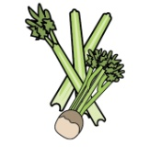 |  | 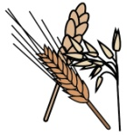 |  | 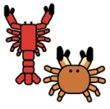 |  |  |  |  |  | 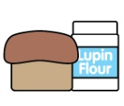 |  |  |  |  |  | 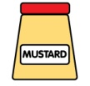 |  | 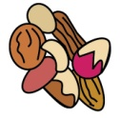 |  | 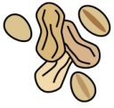 |  | 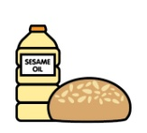
 | Celery |  | Cereals containing gluten |  | Crustaceans |  | Eggs |  | Fish |  | Lupin |  | Milk |  | Mollusc |  | Mustard |  | Nuts |  | Peanuts |  | Sesame seeds |  | Soya |  | Sulphur Dioxide
‘Free from’ fish fingers, chips and vegetables |  |  |  |  |  |  |  |  |  | ✓
Battered fish, chips and vegetables |  |  |  | ✓ |  |  |  | ✓ |  | ✓ |  |  |  | ✓
Chicken goujons, potato lattice/crispies and vegetables |  |  |  | ✓ |  |  |  | ✓ |  |  |  |  |  | ✓
Fishcake, chips and vegetables |  |  |  | ✓ |  |  |  | ✓ |  | ✓ |  |  |  | ✓
Jacket potato with a choice of fillings |  |  |  |  |  |  |  |  |  | ✓ |  |  |  | ✓
Jumbo fish finger, chips and vegetables |  |  |  | ✓ |  |  |  | ✓ |  | ✓ |  |  |  | ✓
Meatballs, rice and vegetables |  |  |  | ✓ |  |  |  | ✓ |  |  |  |  |  | ✓
Pasta bake with vegetables |  |  |  | ✓ |  |  |  | ✓ |  |  |  |  |  | ✓
Pasta with a choice of toppings |  |  |  | ✓ |  |  |  | ✓ |  | ✓ |  |  |  | ✓
Quorn roast dinner |  |  |  | ✓ |  |  |  | ✓ |  |  |  |  |  | ✓ |  |  |  |  |  |  |  |  |  |  |  | ✓
Quorn spaghetti Bolognese |  |  |  | ✓ |  |  |  | ✓ |  |  |  |  |  | ✓ |  |  |  |  |  |  |  |  |  |  |  | ✓
Roast beef dinner |  |  |  | ✓ |  |  |  | ✓ |  |  |  |  |  | ✓
Roast turkey dinner |  |  |  | ✓ |  |  |  | ✓ |  |  |  |  |  | ✓
Sausages, sautéed potatoes and vegetables |  |  |  | ✓ |  |  |  | ✓ |  |  |  |  |  | ✓ |  |  |  |  |  |  |  |  |  |  |  |  |  | ✓
Spaghetti Bolognese |  |  |  | ✓ |  |  |  | ✓ |  |  |  |  |  | ✓
Vegan sausage roll, hash brown and vegetables |  |  |  | ✓ |  |  |  | ✓ |  |  |  |  |  | ✓ |  |  |  |  |  |  |  |  |  |  |  | ✓
Veggie burger, chips and vegetables |  |  |  | ✓ |  |  |  | ✓ |  |  |  |  |  | ✓ |  |  |  |  |  |  |  |  |  |  |  | ✓
Veggie fingers, potato lattice/chips/potato crispies and vegetables |  |  |  | ✓ |  |  |  | ✓ |  |  |  |  |  | ✓
Veggie meatballs, rice and vegetables |  |  |  | ✓ |  |  |  | ✓ |  |  |  |  |  | ✓ |  |  |  |  |  |  |  |  |  |  |  | ✓
Veggie sausages, sautéed potatoes/chips and vegetables |  |  |  | ✓ |  |  |  | ✓ |  |  |  |  |  | ✓ |  |  |  |  |  |  |  |  |  |  |  | ✓

Review date: 02/12/2021 |  | Reviewed by: | T. Mabbitt | 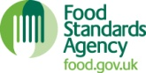 | You can find this template, including more information at www.food.gov.uk/allergy

