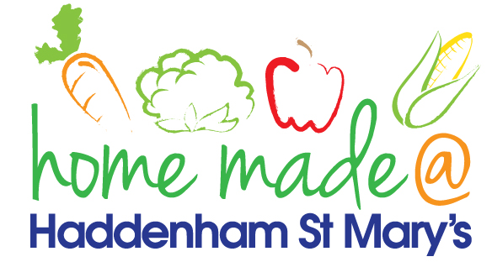

MENU – week commencing 27th September 2021
 | Meat Free Monday | Tuesday  Choose Day | Wednesday  Wonderful Roast | Thursday  Julie’s Jackets | Friday  Fish Friday
Lunch | Tomato and mozzarella pasta | Teriyake chicken and rice | Roast beef with all the trimmings and gravy | Jacket potato with a choice of toppings | Breaded plaice goujons, chips and vegetables
Vegetarian option | Tomato and mozzarella pasta | Teriyake quorn and rice | Quorn roast with all the trimmings | Jacket potato with a choice of toppings | Vegetable fingers, potato chips and vegetables
Dessert | Mandarin segments | Yoghurt | Muffin | Fruit | Biscuit
Free From  option | Tomato pasta  Mandarin segments | Teriyaki chicken and rice  Custard | Roast beef with all trimmings and gravy  Biscuit | Jacket potato with a choice of toppings  Fruit | Fish fingers, chips and vegetables  Biscuit
All meals will contain or be served with at least one portion of vegetables.
All hot puddings will be accompanied by custard or cream.
All roast dinners, sausage & mash and pie dishes will have the option of extra gravy.
All children will also be offered bread, a piece of fruit and a drink of milk or water with their main meal.

