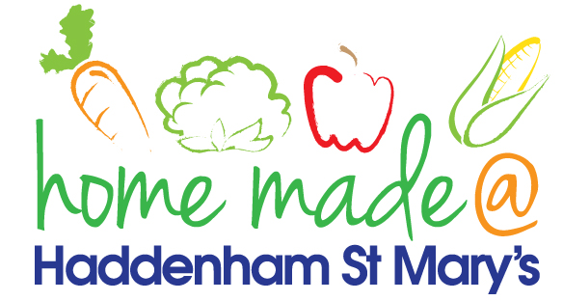

MENU – week commencing 6th September 2021
 | Meat Free Monday | Tuesday  Choose Day | Wednesday  Wonderful Roast | Thursday  Julie’s Jackets | Friday  Fish Friday
Lunch | Vegetable stir-fry and rice | Sausages, sautéed potatoes and vegetables | Roast turkey with all the trimmings and gravy | Jacket potato with a choice of toppings | Jumbo fish fingers, chips and vegetables
Vegetarian option | Vegetable stir-fry and rice | Veggie sausages, sautéed potatoes and vegetables | Veggie sausage roast with all the trimmings | Jacket potato with a choice of toppings | Vegetable slice, chips and vegetables
Dessert | Peach slices | Sponge and custard | Flapjack | Fruit | Cake
Free From  option | Vegetable stir-fry and rice  Peach slices | Sausages, sautéed potatoes and vegetables  Custard | Roast turkey with all trimmings and gravy  Biscuit | Jacket potato with a choice of toppings  Fruit | Fish fingers, chips and vegetables  Biscuit
All meals will contain or be served with at least one portion of vegetables.
All hot puddings will be accompanied by custard or cream.
All roast dinners, sausage & mash and pie dishes will have the option of extra gravy.
All children will also be offered bread, a piece of fruit and a drink of milk or water with their main meal.

