Dear Parent/ Carer,

I am now able to offer brass lessons at your school.
Children can play any brass instrument they like dependant on suitability, due to size, and ease of use. Instruments include: Trumpet, Cornet, trombone, horn, euphonium, and tuba.

I have worked as a peripatetic music teacher in Buckinghamshire for eighteen years, and before that played professionally in orchestras, jazz and pop groups.
I hold all the necessary and up to date Disclosure and Barring service certification (DBS), formerly criminal records bureau (CRB).

Lessons will be individual or in groups of two with 20 or 30 minute sessions available.
Fees are paid in advance on a termly basis and a total of 33 sessions will be delivered in an academic year. A terms notice is required if you wish to stop lessons.
(Shared lessons are dependant on suitable groupings and enough students to share)
Please confirm your preferred lesson length and if you would like shared or individual. (I need this information to compile timetables.)

The fees are:
2019/20 fees:
30 minute individual lessons is £192 per term
20 minute individual lessons is £129per term
30 minute shared lesson is £97 per term
20 minute shared lesson is £67 per term

A terms notice is required to stop lessons.

Cheques must be made payable to Mr S Kitchen or you can pay by BACS (sort code 60-01-31 and account no. 50623990). Please use your child's name for the reference.

If you would like to take up this opportunity or would like to discuss and queries, please contact me via email as soon as possible rjkitchen@sky.com.

Best wishes
Steve Kitchen
F.L.C.M. L.L.C.M A.L.C.M

Beginners will need an instrument, it is best to shop around to get the best deals.

For brass the best shops in the area are: Prozone music www.prozonemusic.com ;
Rosehill instruments www.rosehillinstruments.co.uk
and Dawkes instruments www.dawkes.co.uk

A book will also be needed: trumpets /cornets/Horn/Euphonium- A tune a day book 1 for trumpet
Trombone - A tune a day book 1 for trombone bass clef edition

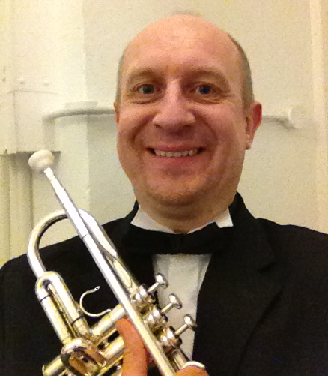
Steve Kitchen F.L.C.M L.L.C.M A.L.C.M. Dip.Hum.

Steve started playing the cornet aged 11 in local brass bands and also the Aylesbury Music centre.
He then studied at the London College of music, gaining a scholarship for a post-graduate year. While at college he played 1st trumpet with the British Youth opera and principle cornet with the Newham brass band and the Young Ambassadors brass band of Great Britain.

After leaving college Steve worked as a freelance trumpeter, and played a wide range of music in various ensembles. As well as 1st trumpet with the Britten sinfonia he has also recorded and toured with pop groups such as the Boo Radleys and the Beautiful South.
He has appeared at the Reading, Glastonbury and the Lollapalooza festivals and television on shows such as Top of the Pops and Later with Jools Holland. His interest in jazz has also seen him perform at the North Sea and Montreux jazz festivals.

After working for Buckinghamshire music service for eighteen years he is again now a freelance teacher and trumpet player, still playing in many varied groups including the Desford Colliery Band, a 70s disco band, and Orchestras, jazz and brass groups.

