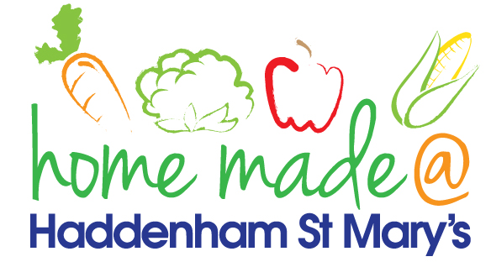

MENU – week commencing 31st January 2022
**Please note that the fish on a Friday may be substituted for a similar fish on the day due to current supply issues**
 | Meat Free Monday | Tuesday  Choose Day | Wednesday  Wonderful Roast | Thursday  Joyful Jackets | Friday  Fish Friday
Lunch | Pasta bake with vegetables | Meatballs, rice and vegetables | Roast beef with all the trimmings and gravy | Jacket potato with a choice of toppings | Jumbo fish finger, chips and vegetables
Vegetarian option | Pasta bake with vegetables | Quorn meatballs, rice and vegetables | Quorn roast with all the trimmings and gravy | Jacket potato with a choice of toppings | Veggie fingers, chips and vegetables
Dessert | Pineapple slices | Mousse | Fruit | Yoghurt | Tutti Frutti sponge
Free From  option | Pasta bake with vegetables  Pineapple slices | Meatballs, rice and vegetables  Biscuit | Roast beef with all trimmings and gravy  Fruit | Jacket potato with a choice of toppings  Yoghurt | Fish fingers, chips and vegetables  Biscuit
All meals will contain or be served with at least one portion of vegetables.
All hot puddings will be accompanied by custard or cream.
All roast dinners, sausage & mash and pie dishes will have the option of extra gravy.
All children will also be offered bread, a piece of fruit and a drink of milk or water with their main meal.

