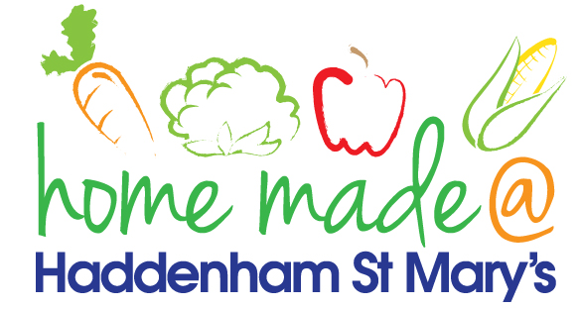

MENU – week commencing 17th January 2022
**Please note that the fish on a Friday may be substituted for a similar fish on the day due to current supply issues**
 | Meat Free Monday | Tuesday  Choose Day | Wednesday  Wonderful Roast | Thursday  Joyful Jackets | Friday  Fish Friday
Lunch | Vegan sausage roll, hash brown and vegetables | Spaghetti Bolognese | Roast beef with all the trimmings and gravy | Jacket potato with a choice of toppings | Battered fish, chips and vegetables
Vegetarian option | Vegan sausage roll, hash brown and vegetables | Quorn spaghetti Bolognese | Quorn roast with all the trimmings | Jacket potato with a choice of toppings | Veggie sausage, chips and vegetables
Dessert | Fruit salad | Yoghurt | Muffin | Fruit | Shortbread
Free From  option | Corn fritter, hash brown and vegetables  Fruit salad | Spaghetti Bolognese  Yoghurt | Roast beef with all trimmings and gravy  Biscuit | Jacket potato with a choice of toppings  Fruit | Fish fingers, potato lattice and vegetables  Jelly
All meals will contain or be served with at least one portion of vegetables.
All hot puddings will be accompanied by custard or cream.
All roast dinners, sausage & mash and pie dishes will have the option of extra gravy.
All children will also be offered bread, a piece of fruit and a drink of milk or water with their main meal.

